

**NEF6002 Research Project B**

**Lung Cancer Detection**

**Student Name**

A minor thesis in partial fulfillment of the requirements for the degree of

Master of Applied Information Technology

**College of Engineering and Science, IT Discipline**

**Victoria University Sydney, Australia**

**June 2020**

# **Abstract**

The topic of this assignment is “Lung Cancer Detection”. In this assignment, I will explain the process of lung cancer detection. The techniques for detecting lung cancer will be defined and specified in this assignment report. Lung cancer is one of the most dangerous diseases in the world and there are numerous patients of this disease are available all over the world. The early diagnosis of this disease is the only way to save a life. And for this early diagnosis process, there is some technology-based approaches are also available that helps to diagnose or detect lung cancer. In the medical field, the CT scan imaging is one of the most important and most widely used technology. The computer-aided diagnosis process has an impact on the medical sector that gives multiple solutions for any kind of problem. The image processing technique is the best way to analyze CT scan images. In the diagnosis of lung cancer, all this technology is to be used. In this assignment, I will explain every possible factor of all of this technology to explain the identification and detection of lung cancer.

Declaration

I, ________________, hereby solemnly declare that this thesis contains no material that has been accepted for the award of any other degree or diploma in any other college, institute, or university and is the result of my research. To the best of my knowledge, this thesis contains no material previously published or written by another person, except where references have been made in the text of the thesis.

Signature: ___________________

Name: _______________________

Date: _______________________

# **Acknowledgments**

Supervisor and anyone who helped you:

I would like to express my special appreciation and thanks to …etc.

.

Table of Contents

**Abstract** ii

**Declaration** iii

**Acknowledgements** iv

**List of Figures** vii

**Glossary and List of Acronyms** viii

**1** **Introduction** 1

**2** **Literature Review** 2

**2.1** **Some related studies** 2

**2.2** **Other related studies** 2

**3** **Research Methodology** 3

**3.1** **Research problem and questions** 3

**3.2** **Selection of research methodology** 3

**3.3** **Other details** 3

**4** **Experimental** 4

**4.1** **Experimental design** 4

**4.2** **Data collection** 4

**4.3** **Data analysis** 4

**5** **Results** 5

**5.1** **Presentation of results** 5

**5.2** **Key Results** 5

**6** **Discussion** 6

**6.1** **Discussion of Results** 6

**7** **Conclusions** 7

**Appendices** 8

**References** 9

# **List of Figures**

Figure 1: Image Processing Stage of Lung Cancer 2

Figure 2: Methods of image processing technique 2

Figure 3: Methodology 3

Figure 4: CT scan Input Image 4

# **Glossary and List of Acronyms**

For example,

|  |  |
| --- | --- |
| API | Application Programming Interface |
| Bash | Bourne-again shell |
| dB | Decibel |
| DLP | Data Loss Prevention |
| GPS | Global Positioning System |
| HTTP | HyperText Transfer Protocol |
| TCP | Transmission Control Protocol |

# **Introduction**

The research topic is based on “Lung Cancer Detection”. Lung cancer is one of the most dangerous diseases and many patients are suffering from this. This research aims to identify and explain the detection technique of lung cancer. Technology is growing every day and in the healthcare sector also the impact of technology is very effective. Doctors are using numerous technologies for their operation. There are latest machines are now available. In the detection process of lung cancer, the technology has an impact and have made this process very easy. The technique is most widely using the image processing technique and this technology is most widely used in many medical areas. This technology helps in earlier detection of disease and treatment process. The factor of this technology is image quality and accuracy. This image segmentation technique enhanced the operating way of the medical sector (Karam M, 2019).

**Keywords:** Lung cancer detection, CT scam image, image processing

The research topic is quite interesting and from the last few years, there has been a lot of discussion on this research topic. There are multiple resources are available for this research area. The reason is that technology has become an essential part of our daily life. In every sector nowadays technology is providing and giving their services. In the healthcare or medical sector also the technology has become an important part. Doctors are using video conferencing for the successful completion of the operation. There are many machines are available that use internet-based technology. In the process of lung cancer detection, technology is very important because using the image processing or image segmentation technique has become an essential part of the CT scan. This technology gives an instant result and output of body scanning (Mokheld S, 2020). There are numerous different types of lung cancer which are divided into two sections such as:

* Small cell lung cancer
* Non-small cell lung cancer

This divided lung cancer has three different subtypes such as:

* Carcinoma
* Adenocarcinomas
* Squamous cell carcinomas

The motive of this assignment report is to analyse and identify the technological factors that help in the process of lung cancer detection. The image processing technique is the only and best way of the early diagnosis process and most widely used also. The image processing technique is directly connected to the CT scan image technology that use to get a quick report of the body scanning image. The CT scan is known as computed tomography (CT) scan. Computer tomography and radiographs are the main components that help in the early detection of lung cancer. This process is also known as a biopsy (Shukla A, 2020).

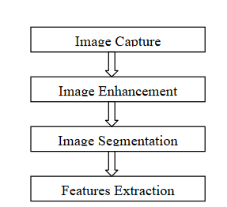

Figure : Image Processing Stage of Lung Cancer

In the given image the stages of lung cancer have been identified and given. This is a liner stage that uses the process of image capture, image enhancement, image segmentation, and feature extraction. This process of lung cancer is divided into two parts such as preprocessing and segmentation. These two factors are directly or indirectly connected or linked to each other.

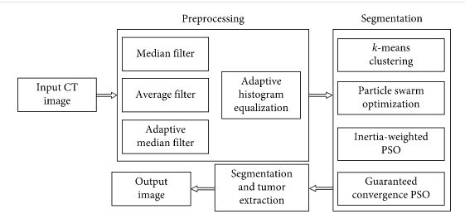

Figure : Methods of image processing technique

The given image is about the methodology of the image preprocessing technique in the implementation of lung cancer detection. Image preprocessing is the most important very crucial aspect which is used to enhance the features and to remove the noise factor present in the image. In the implementation of image preprocessing, one of the most important factors is filtering. There are multiple filtering processes are available in this image preprocessing and every single filtering process is directly or indirectly connected or linked to each other (Sangam S, 2020).

Image segmentation is the process of an effective process for image analysis tasks. In the implementation process of image segmentation the digital image use to divide into multiple segments. There are numerous operations are available in the process of image segmentation such as edge detection, thresholding, watershed transform and many more.

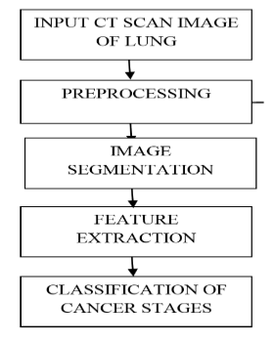

Figure : Methodology

The given image is about the methodology of the lung cancer detection and there is a step by step process is given in this flor chart. The process is associated or related and has an impact on the detection process of lung cancer (Luciani T, 2020).

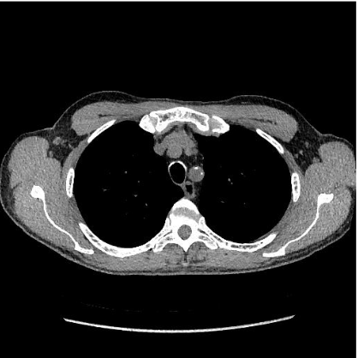

Figure : CT scan Input Image

The given image is about the CT scan input image. The filtering is one of the most important and very important factors because after using the functionality of image filtering the disease detection process can be very easy. In this CT scan image, the proper image of the lung has been identified and every angle is visible but this image can further improve and for that process, the concept of image pre-processing is used.

# **Research Significance**

The impact of technology is everywhere and many business organizations are attractively using technology. The medical field is also using the functionality of internet technology that gives an advanced enhancement to do their work. I will identify the impact of technology in the medical sector and the topic on which this assignment is based on lung cancer detection. Technology has made this detection process very easy by executing the image processing technique with computed tomography (CT) scan image. The technique of image processing has an impact on society, enterprise, and the business organization also. To understanding this concept I am analysing research paper based on this given topic and many other resources also (Parab C, 2020).

The lung cancer detection process is somehow related to technology and using the features and functionality of internet technology. It is quite easy to write on technical base research because most of the resources are available on multiple websites, journals and many more. I am analysing each journal very deeply so that I can understand the advantages and disadvantages of using the image processing technique in the detection of lung cancer.

# **Literature Review**

* Try to narrow the research field that you talked about in the introduction into the specific area,
* complete a structured, critical review of theoretical and experimental literature on the topic area
* Write about when and how and why this research field become attractive to the other researchers
* Explain methodologies, hardware, software, tools applicable in the field. Explain about the future research trend
* Discuss the thesis topic and your research contribution
* Try to categorize the literature background
* Updates from NEF6001.

# **Some related studies**

# **Other related studies**

# **Research Methodology**

The structure in the chapter is just for reference. You need to name and organize various sections. Expand from NEF6001.

# **Research problem and questions**

* Define a problem from contemporary and emergent settings
* My research problem
* The answer of how you want to do it will form the next section that it is “Research Methodology

# **Selection of research methodology**

# **Other details**

# **Experimental**

Expand from NEF6001

* How have you extended your research from Research Thesis 1.
* Information to allow the reader to assess your results.
* Procedure, theory.
* Calculations, technique, procedure, equipment.
* Limitations, assumptions, and range of validity.
* Desciption of your analystical methods.

*Do not* include descriptions of results.

* 1. **Experimental design**
  2. **Data collection**
  3. **Data analysis**

# **Results**

This chapter can be merged with the previous chapter.

* The results are statements of observations, including statistics, tables and graphs.
* Mention negative results as well as positive.
* Do not interpret results, this should be done in Discussion chapter.
* Break up your results into logical segments by using subheadings.
  1. **Presentation of results**

Summarise and present the results, figures, tables

* 1. **Key Results**

Key results should be stated in clear sentences at the beginning of paragraphs.

# **Discussion**

* Start with a few sentences that summarize the most important results. The discussion section should be a brief essay in itself, answering the following questions and caveats:
* What are the major observations?
* What are the trends?
* Explain reasons for the patterns and resulting predictions?
* Do you agree or disagree with previous research?
* Interpret results in terms of background laid out in the introduction.
* How are your result relate to the original question?
* Discuss the implications of the results.
* Multiple hypotheses. There may be a number of possible expanations for results.
* Anything you’ve learned we didn't know or understand before the present work?
  1. **Discussion of Results**

Break up the section into logical segments by using subheaders.

# **Conclusions**

* Conclude what you have done and write about your findings and if possible, point out some future work
* Most important statement that you can make from your observations.
* What conlusion you offer about the original problem posed?
* Include the broader implications of your results.
* Do not repeat word for word the abstract, introduction or discussion.

# **Appendices**

# **References**

* Afroze, R., Atikur, M. and Karam, M., 2019. Detection of Lung Nodules using Image Processing Techniques. *International Journal of Computer Applications*, 177(19), pp.31-37.
* Mokheld, S, 2020. [online] Lejpt.academicdirect.org. Available at: <http://lejpt.academicdirect.org/A20/147_158.pdf> [Accessed 11 April 2020].
* Shukla, A., Parab, C., Patil, P. and Sangam, S., 2020. [online] Irjet.net. Available at: <https://www.irjet.net/archives/V5/i4/IRJET-V5I4559.pdf> [Accessed 11 April 2020].
* Luciani, T., 2020. A spatial neighborhood methodology for computing and analyzing lymph node carcinoma similarity in precision medicine. *Journal of Biomedical Informatics: X*, 5, p.100067.